Project Development Phase
Model Performance Test

Date | 08 September 2026
Team ID | SWUID2026190415
Project Name | Medical Diagnosis Center by Service Portal (ServiceNow)
Maximum Marks | 10 Marks

Model Performance Testing:
Project team shall fill the following information in model performance testing template.
S.No. | Parameter | Values | Screenshot
 | Metrics | Regression Model  - MAE – Not Applicable (N/A)  - MSE – Not Applicable (N/A)  - RMSE – Not Applicable (N/A)  - R² Score – Not Applicable (N/A)  Classification Model  - Confusion Matrix – Not Applicable (N/A)  - Accuracy Score – Not Applicable (N/A)  - Classification Report – Not Applicable (N/A)  Reason: This project is developed using the ServiceNow platform and does not use any Machine Learning or Classification model. | 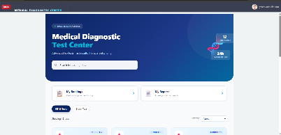
 | Tune the Model | Hyperparameter Tuning: Not Applicable (N/A)  Validation Method: Functional testing, workflow testing, appointment booking validation, report generation validation, and role-based access validation were performed in ServiceNow. | 